Krystalografická společnost
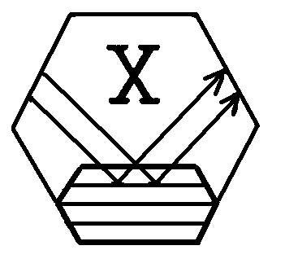
Regionální komitét českých a slovenských krystalografů

Ústav makromolekulární chemie AV ČR
si Vás dovolují pozvat na

256. ROZHOVORY

Inhibition of Serine and Aspartic Proteases

Čas: pondělí 25. 11. 2002
Místo: Ústav makromolekulární chemie AV ČR, posluchárna B
Doprava: Konečná tramvají 1, 2, 18 na Petřinách.

Topics:

X-ray diffraction, molecular modeling and dynamic studies of enzymatic reactions, inhibition of HIV protease, drug design, theoretical analysis of enzymatic reactions, protein crystallography

13.00-13.30 Mariusz Jaskolski (Poznan, PL)

Atomic Resolution Structures of Trypsin Inhibitors

13.30-14.00 Grzegorz Bujacz, Natasza Ziolkowska (Technical University, Lodz, PL)

Structural investigation of HIV-1 protease inhibitors

14.00-14.20 Jiří Brynda (Inst.of Molecular Genetics, Acad.Sci., Praha, CZ)

High Resolution Structure of HIV1 Protease – Inhibitor Komplex

14.20-14.50 Break

14.50-15.10 Tereza Skálová (Inst.of Macromolecular Chemistry, Acad.Sci., Praha, CZ)
Structural and Energy Comparison of Ethyleneamine Inhibitor Binding
to the Wild and Mutant HIV Proteases

15.10-15.30 Eva Buchtelová (Inst.of Macromolecular Chemistry, Acad.Sci.,Praha, CZ)
Product of Autoproteolytic Cleavage Found in the Active Site of HIV Protease by X-ray Crystallography

15.30-16.00 Karel Zimmermann (INRA Paris)
Soft Block Constraints in Energy Minimization – HIV protease experiments

16.00-17.00 Discussion

There is no fee and no preliminary registration is required. However, if you like to be informed about the program changes or to receive written materials or have your own contribution to the seminar, please send a short message to address hasek@imc.cas.cz

Abstracts or written records of lectures are welcome. Contributions under 500 words will be considered as abstracts and published as they are. Longer contributions will pass standards reviewing procedure in the journal. Abstracts of lectures will be published in 2003 in the journal Materials Structure, ISSN 1211-5894, Vol.10, no.1, 2003.

